**Browsi Optimization Manager Test - Omer Shilo**

Part 1 – SQL

1. What are the 3 most expensive products in order 10252 and what is their price?

SELECT P.ProductID,P.ProductName,P.Price

FROM Orders AS O JOIN OrderDetails AS OD ON O.OrderID=OD.OrderID JOIN Products AS P ON OD.ProductID=P.ProductID

WHERE O.OrderID=10252

ORDER BY P.Price DESC

LIMIT 3

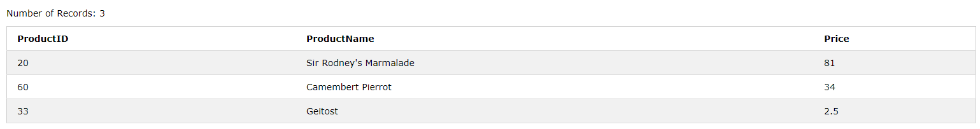

1. Who is the customer from Madrid or London that ordered the largest order? (show their name, city and quantity of products)

SELECT C.CustomerName,C.City,Sum(OD.Quantity) AS TotalQuantity

FROM Customers AS C JOIN Orders AS O ON C.CustomerID=O.CustomerID JOIN OrderDetails AS OD ON O.OrderID=OD.OrderID

WHERE C.City='Madrid' OR C.City='London'

GROUP BY C.CustomerName,C.City

ORDER BY TotalQuantity DESC

LIMIT 1

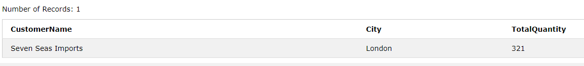

3) What is the average price per categoryID of orders shipped by Federal Shipping in

1997?

SELECT P.CategoryID, AVG(P.Price) AS "Average price"

FROM Orders AS O JOIN OrderDetails AS OD ON O.OrderID = OD.OrderID JOIN Shippers AS S ON O.ShipperID = S.ShipperID JOIN Products AS P ON OD.ProductID=P.ProductID

WHERE S.ShipperName ='Federal Shipping' AND year(O.orderDate) = '1997'

GROUP BY P.CategoryID

ORDER BY P.CategoryID ASC

*** there was a problem with the link to w3school with this question,So I used different link to simulate the query (same DB but different number of entries).

<https://www.w3schools.com/sql/trymysql.asp?filename=trysql_func_mysql_year>

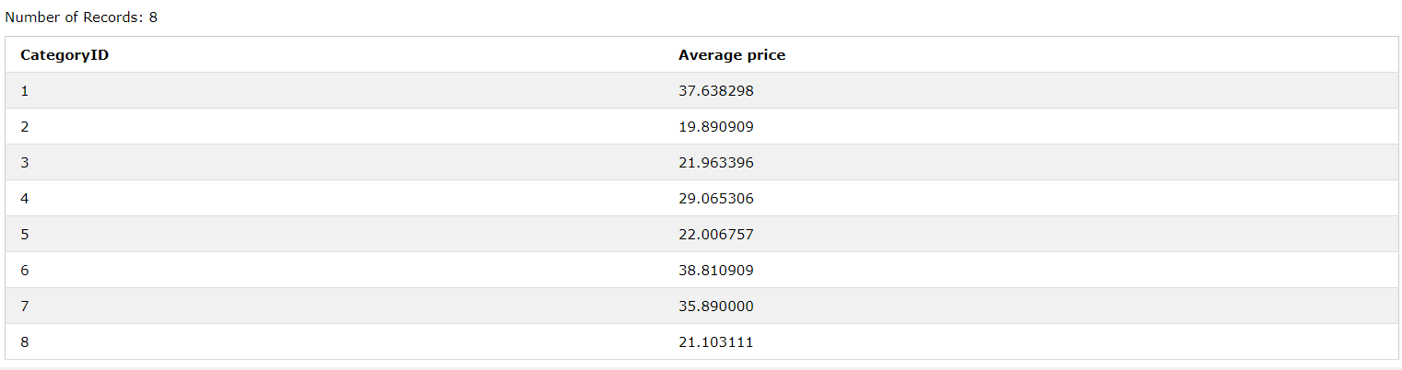

Part 2 – Data Analysis

1. To find the reason for the drop in viewability at site X I had to make some analysis to the data.

First, I have checked if there is any drop in the viewability at the Oss’ in compare to all the three dates. From the graph you can tell that there is obvious drop in viewability at the IpadOS, Tizen OS and slightly at BlackBerryOS.

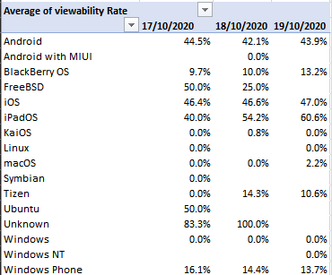

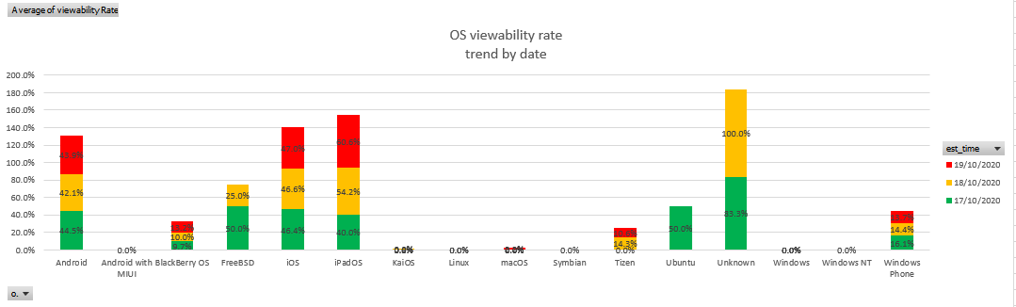

Because drop in the Oss’ viewability does not relate to the company I have decided to dig deeper and check whether there is a problem with one of the company’s versions (which run on the browsers). From the graph you can see that there is indeed a drop in ver. 3.5.5 along all the browsers. However in ver.3.5.s.3 there is no drop.

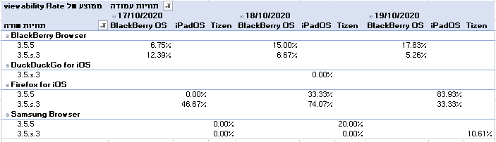

I cannot blame a software version because of 3 apps that has a problem, that is why I have decided to check if there is another browser (at other Oss) which has the same problem.

The following graph shows the browsers which has a drop at viewability on the 17th of October

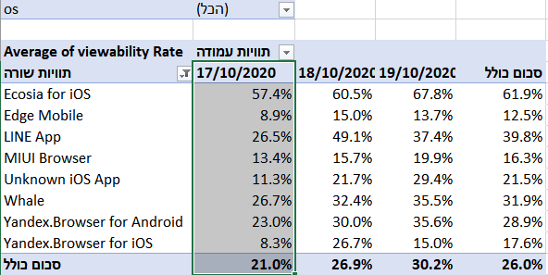

Once again I’ve dug deeper to check whether the version 3.5.5 is indeed problematic.

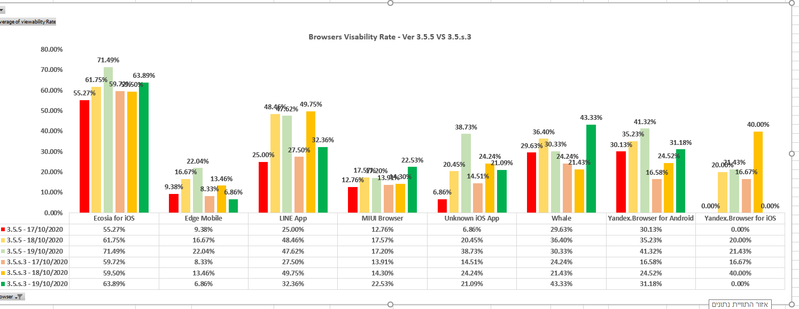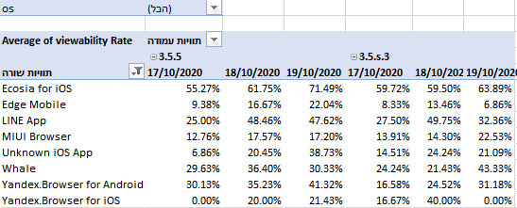

Conclusion:

after dig deep enough into the data I have come to conclusion that at 17th of October the apps which runs the version of 3.5.5 has a problem which cause a drop on visibility rate. Apparently on the 18th and the 19th the problem was solved.

2)

unfilled impression- a field which determine how many ad requests did not return an item, the more unfilled impression the more money goes to waste.

Total code served count – in contrast to unfilled impression the “total code served count” counts how many requests return an item (counts even when there is a delay or error on the client’s side).

Impressions - the field measure how many times an ad shows up for the user. the more impressions the greater the chances to get an engagement(clicks) and raise the revenue.

Total clicks, Total CPM, CPC, CPD, and vCPM revenue = the more the merrier.

Total Active View eligible/measurable/viewable impressions – those parameters count how many times X part of an ad was visible for the user for Y seconds.

“Total active view eligible impressions” is the most forgiving while “Total active view viewable impression” is the least forgiving and therefore gives the best measure for a potential click.

As a company our goal is to locate an ad in a place with the best potential to make more “Total active view viewable impression”.

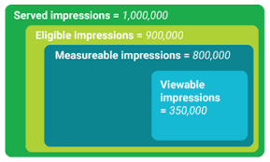

Requests – indicate whether an ad is located at page with a lot of traffic which can increase/decrease the CPMs costs.

Fill rate – indicate whether a page has successfully load with all the ads. If the fill rate is low maybe there is a problem with the ads/page and the money goes to waste.

eCPM – measures how much money each ad makes for 1000 impressions. The higher the number the bigger the revenue per ad.

Viewability – measure how many ads were “viewable” from the “measurable” ads as I mention earlier our goal is to locate an ad in a place with the best potential to make more “Total active view viewable impression”.

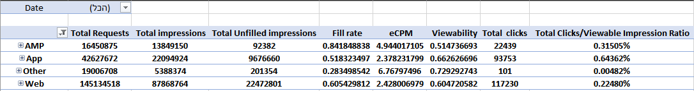

*I have added a field which is calculating the ratio of the clicks against the total of Viewable Impressions – this field give me the information regards how many attractions the ads attract from all the Viewable Impressions.

To increase the revenue, I would recommend a couple optimizations:

1. The Fill Ratio at AMP is the highest but has the lowest requests. I am suggest thinking on a way to increase the number of requests to increase the number of potential impressions due to the high Fill Ratio.

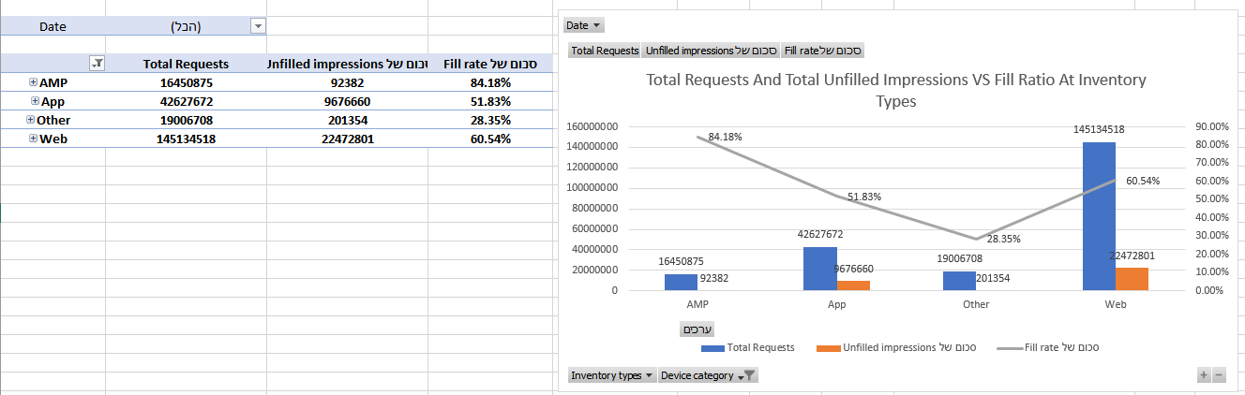

1. Connected TV’s has the highest eCPM and the highest viewability ratio but has very low Fill ratio which means that a lot of ads does not shows up to the user and therefore money goes to waste. I suggest checking why the Fill Ratio is so low and fix that.

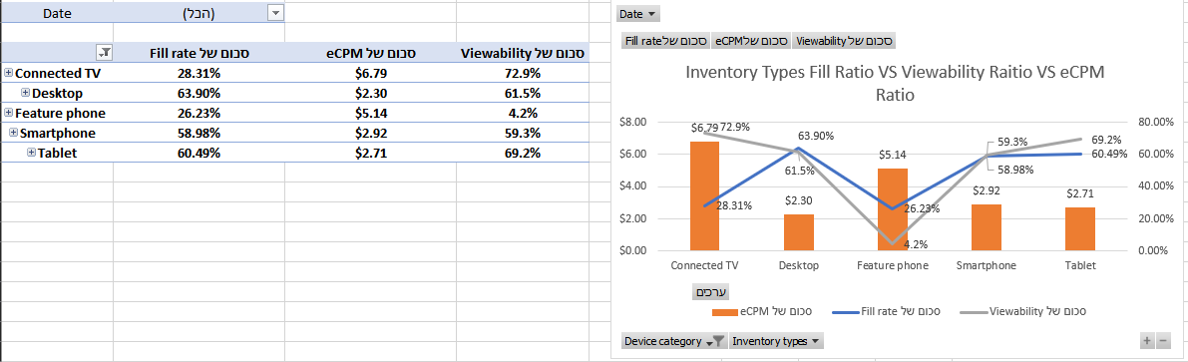

1. From the first graph I can tell that there are more clicks per viewable impression at the apps then the other categories combined. From the second graph I can tell that most of the impressions come from the web. There is two optimization that can happened here. The first, make more apps for the web pages. there is higher probability to get more revenue from ads at the apps. The second, make the CPVI higher at the web and take advantage of the mass of potential impression there.

